Executive Summary for the
Ground-Warfighter Geospatial Data Model version 3.0

Report Date: January 16, 2016

Unclassified

Authors:
Nancy Towne, AGC
Annette Janett Filer, Leidos

Contributors:
Dale Miller, SAIC
Robert Gaines, SAIC

Prepared for:
U.S. Army Geospatial Center

Ground-Warfighter Geospatial Data Model (GGDM) Executive Summary

The U.S. Army Geospatial Center (AGC) is the focal point for the Army Geospatial Enterprise (AGE), which will provide the standards and technology to acquire, manage, and share geospatial data, for the warfighter. The AGE is based upon an integrated data and services architecture that establishes common requirements, standard interfaces and data models. The GGDM is a core component of this architecture. This standards-based approach will help eliminate stovepipes, reduce costs, simplify acquisition and accelerate transition of technology as part of a standard and shareable geospatial foundation.
The Army, U.S. Marine Corps (USMC) and Warfighter Programs plan and operate in varied and unpredictable locales and they require accurate, up-to-date, geospatial analysis and visualization information of varied fidelity and resolution in order to support decision making processes. These ground forces rely on geospatial data products from National, Allied, and commercial sources. They also have requirements to enhance and augment this data with essential in-theater assets. These enhancements often do not “fit” into the schemas provided by traditional geospatial data producers. The heterogeneous variety and volume of geospatial data poses data management problems and interoperability issues. Without well-managed sets of terms and definitions for characterizing geospatial information and services, there will continue to be “islands of data” among Army, USMC and other Warfighter Programs resulting in stove-piped systems and wasteful duplication of geospatial information.
As part of the GGDM development, the ground-warfighters are developing a holistic understanding of the geospatial information needs and data holdings to ensure consistent, efficient and effective use and reuse of geospatial data across systems. Understanding the issues and looking towards increasing interoperability and reuse, AGC has developed the GGDM. The primary focus of the GGDM is to identify, understand and manage geospatial data entities, information concepts, structural relationships, and lineage information in a shareable, accessible common environment for ground forces. The GGDM supports the ground-warfighter within the AGE with a well-defined interoperable schema, data dictionary, and databases that provide a common operational picture while reducing cost due to reuse and automated processes.
The GGDM consists of a logical data model (LDM) schema, a data dictionary, and physical data model (PDM) exemplars intended to support enterprise-wide geoservices across Army and Warfighter Programs. These data models are designed for the collection, maintenance, and dissemination of vector data including features such as roads, rivers, buildings, fences, and boundaries; and identifying attributes related to the features such as function, height, type, physical condition and operational status; and metadata describing the accuracy, content origin, and classification level. The GGDM is the ground-warfighter container into which geospatial data elements may be collected, managed and reused. It provides for unique ground-warfighter extensions falling outside traditional data products to be rapidly included into the model and be made available to ground-warfighter systems. The GGDM also features a tight-coupling with the National System for Geospatial-Intelligence (NSG) allowing for greater interoperability and data sharing between the GGDM and National Geospatial-Intelligence Agency (NGA) NAS.
A Sample of the GGDM information domains are shown in Figure 1.
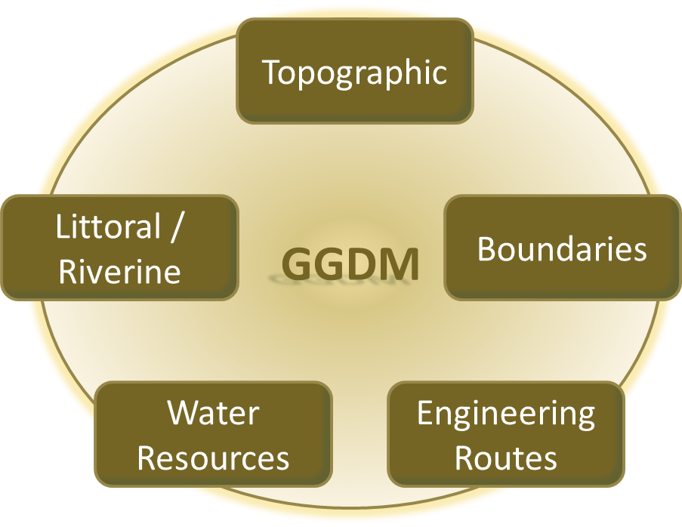
Figure 1 Sample GGDM Domains
Future versions of the GGDM may include force enterprise content, including high resolution urban information, modeling and simulation, installations, tactical information and updates based on common geospatial data requirements across the Army, USMC and other ground forces components. The GGDM 3.0 is currently managed by AGC. The configuration management of the GGDM is managed by the Ground Warfighter Working Group chartered under the NSG Geospatial Working Group.

